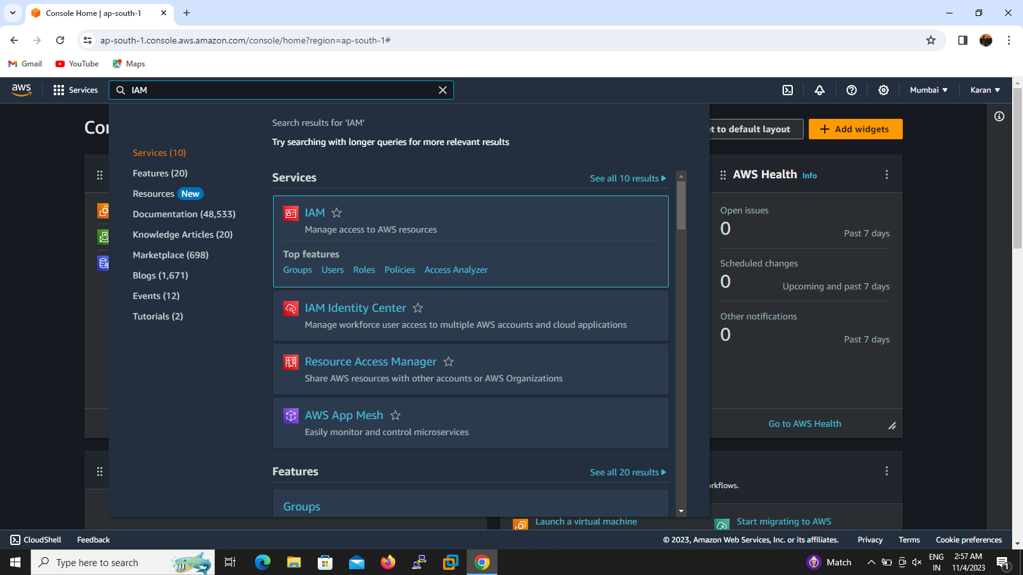

1.To create the IAM ID by does following steps ~ Go to search IAM then click and we want create user with group permissions so I create group then click user groups

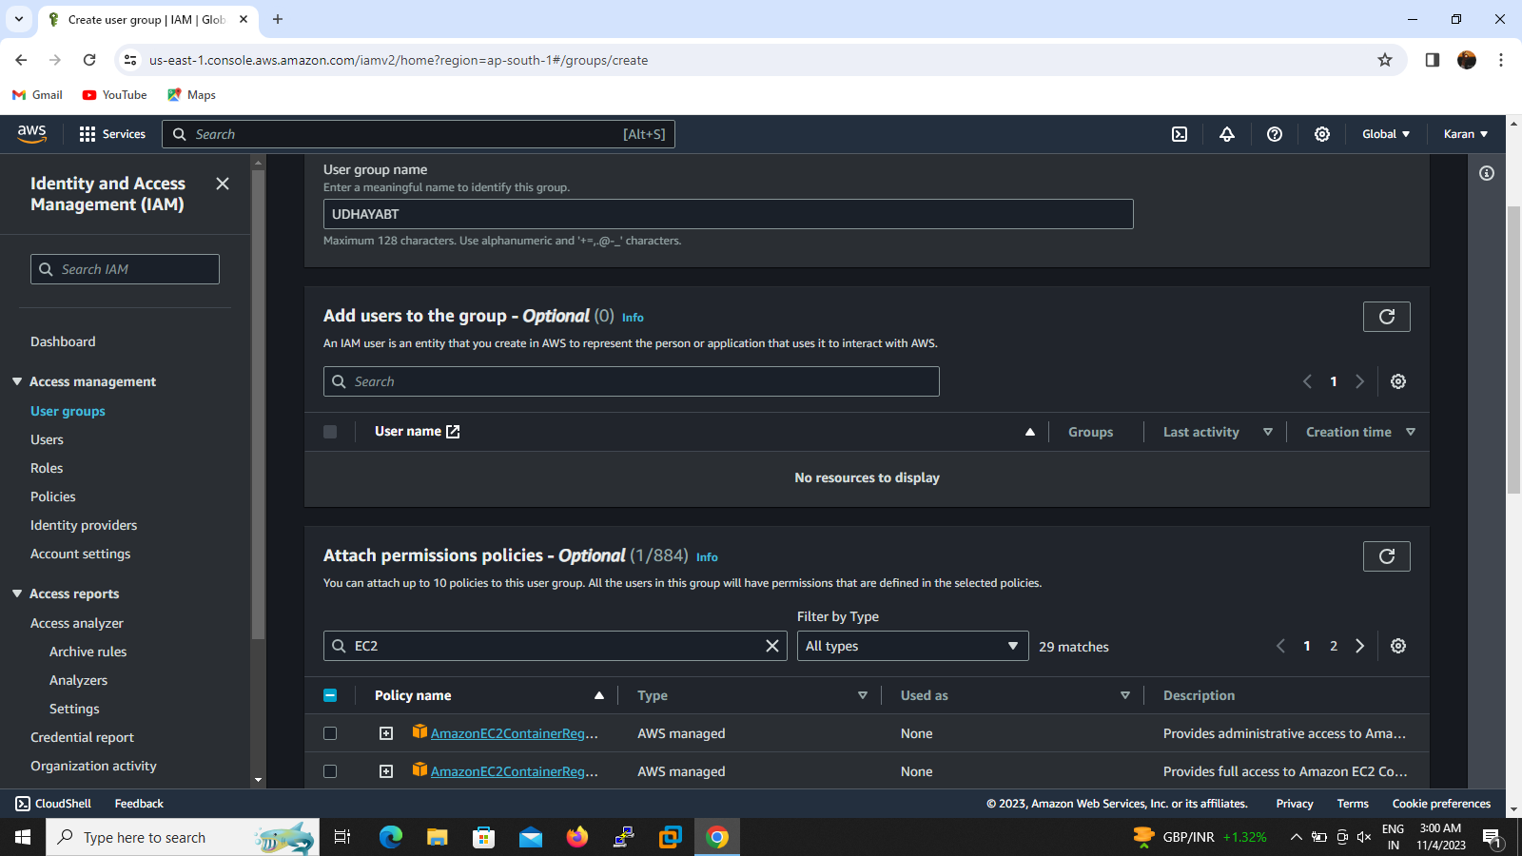

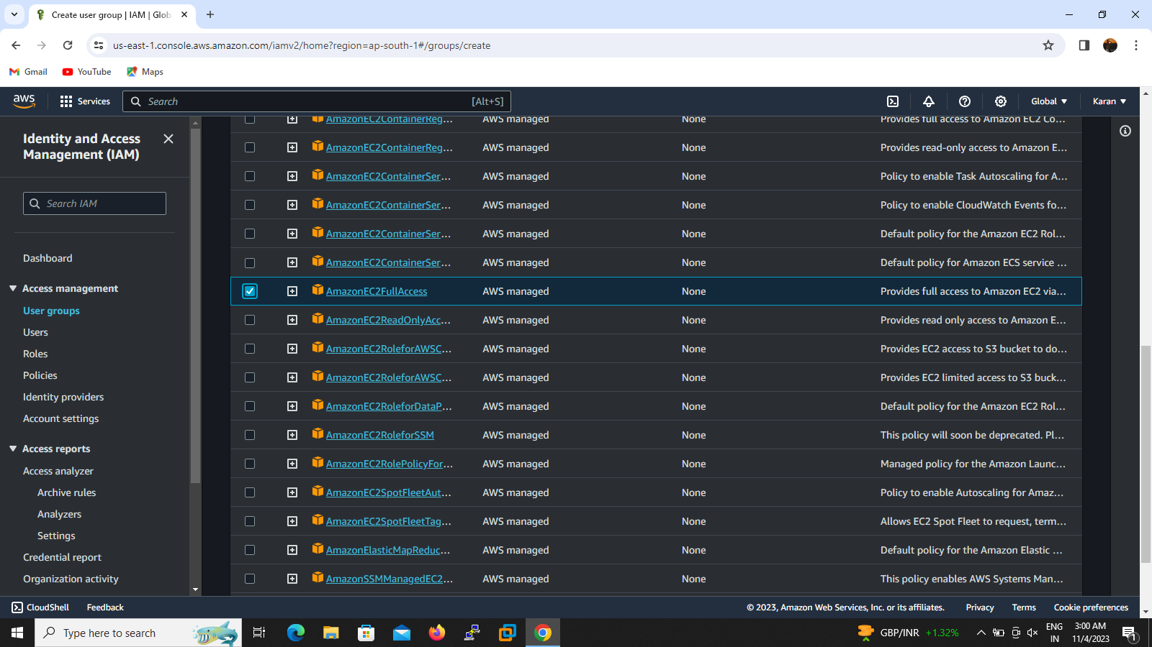

2.select the group permissions we want to access only ec2 so I select ec2 full access and fill the name for the group I create UDHAYABT then created.nxt we want to add a user to this group so go to create user.

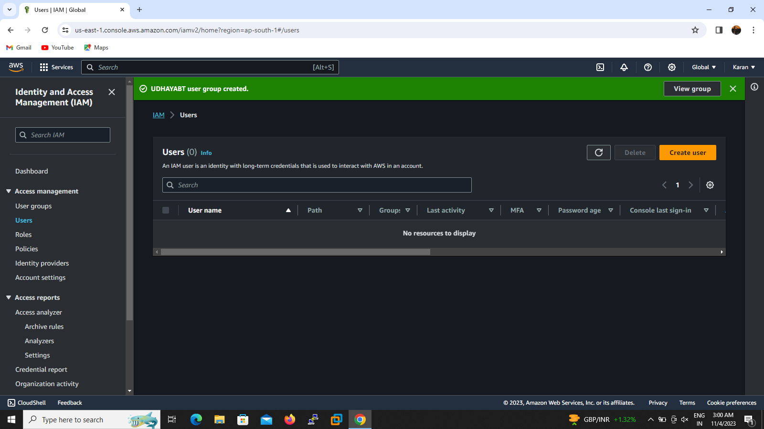

3.click create user

4.select I WANT TO CREATE IAM USER

5.select the add to group option and select the required group then it will be created successfully

6.copy the URL and password

7.If we need ALIAS option to secure my console ID so I go to click alias provide name and the URL will be created successfully.

8.PASTE the URL to another window username and password then reset the password then user login to the console successfully.

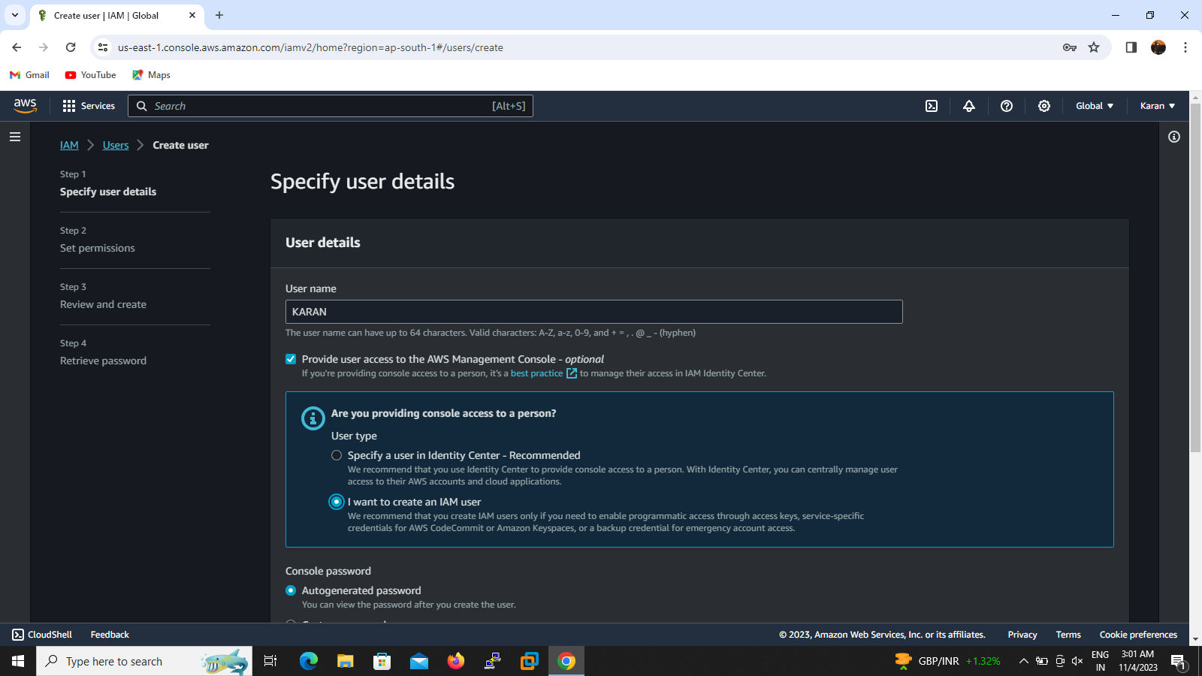

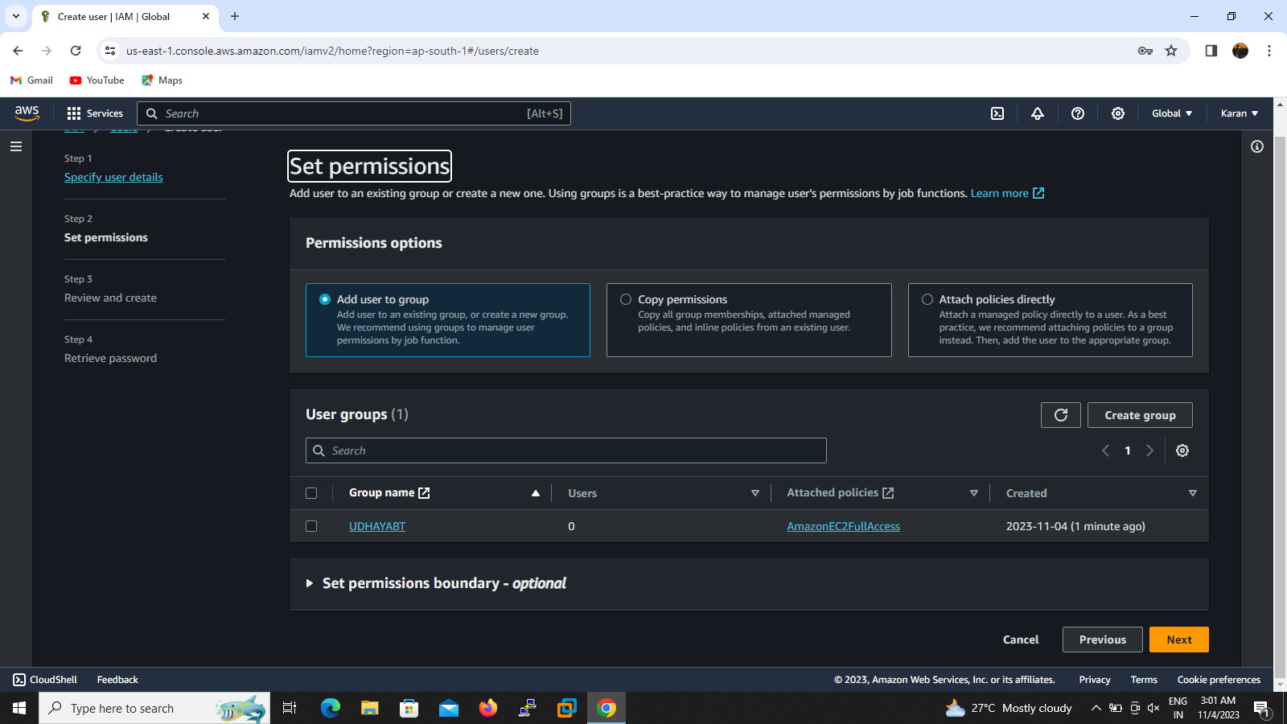

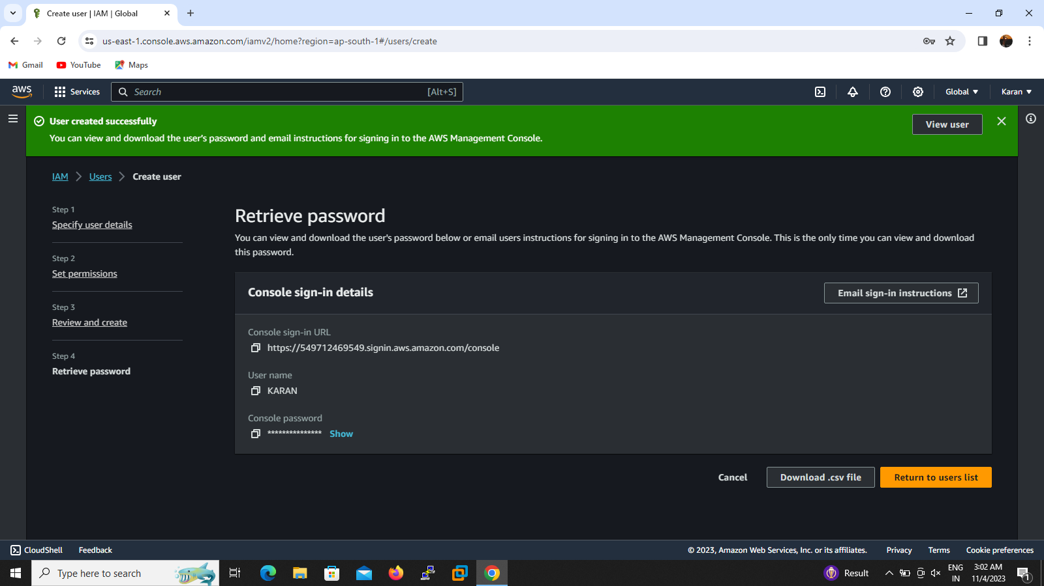

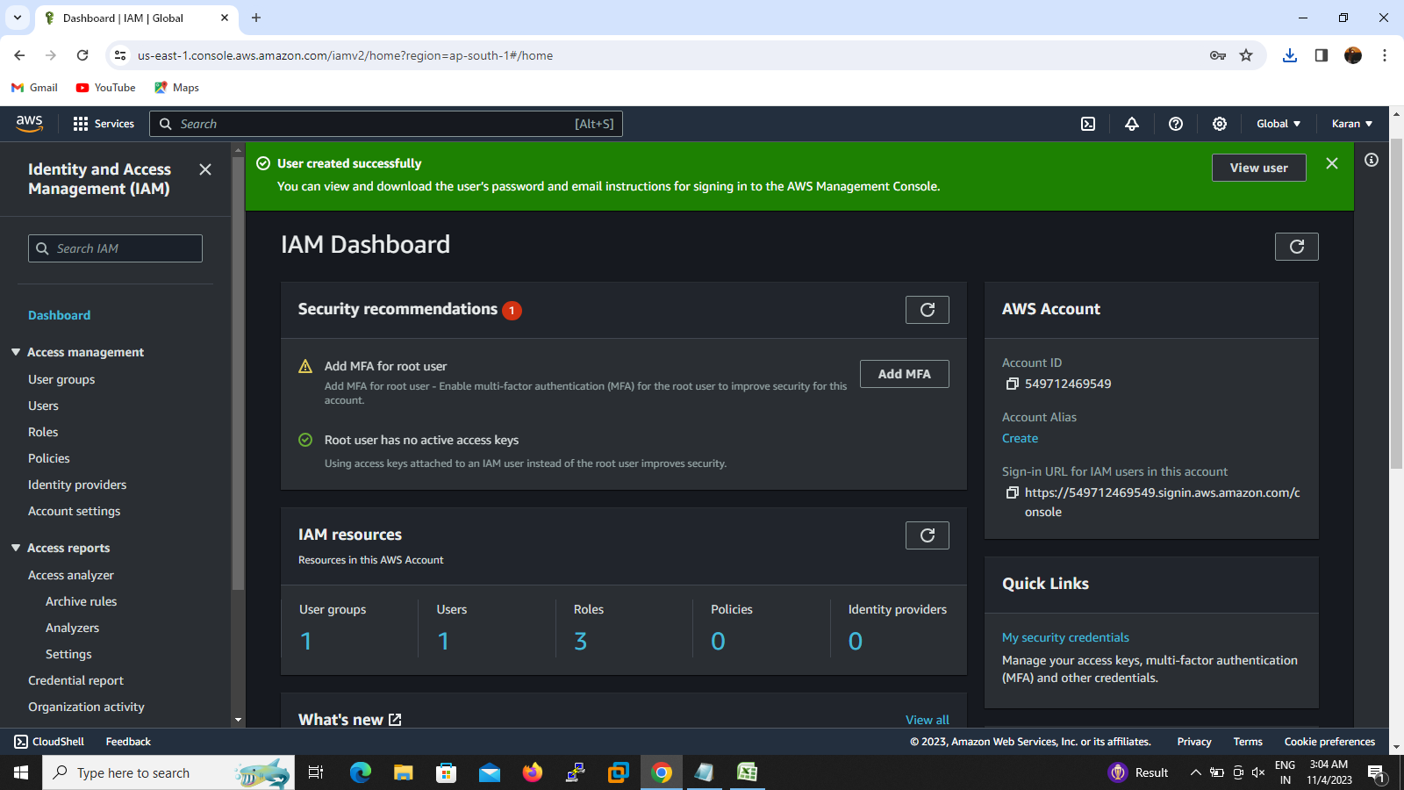

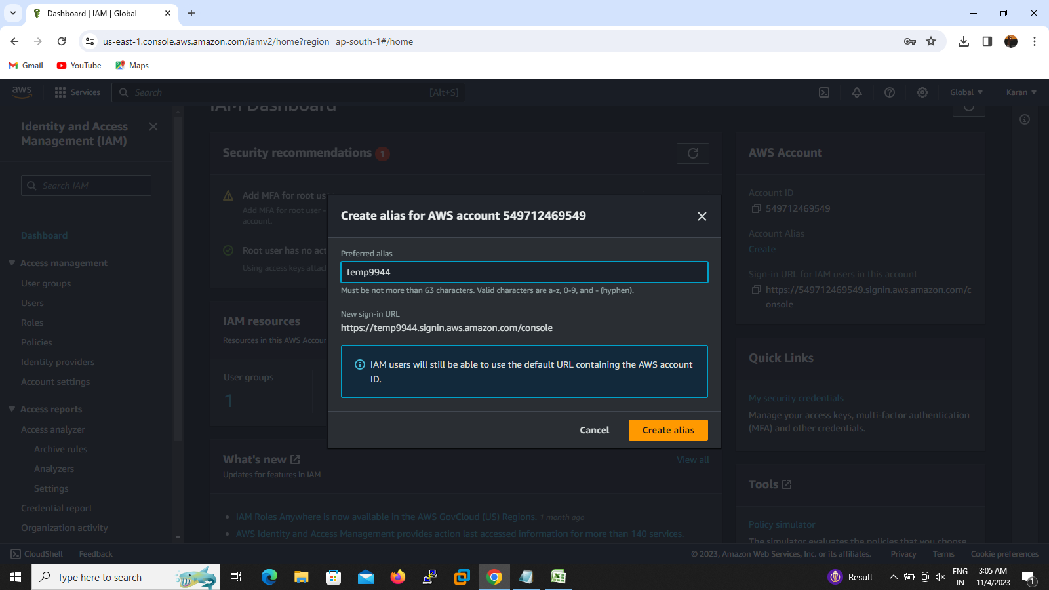

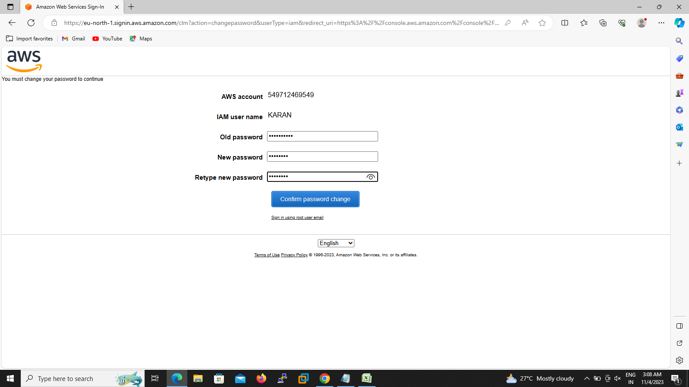

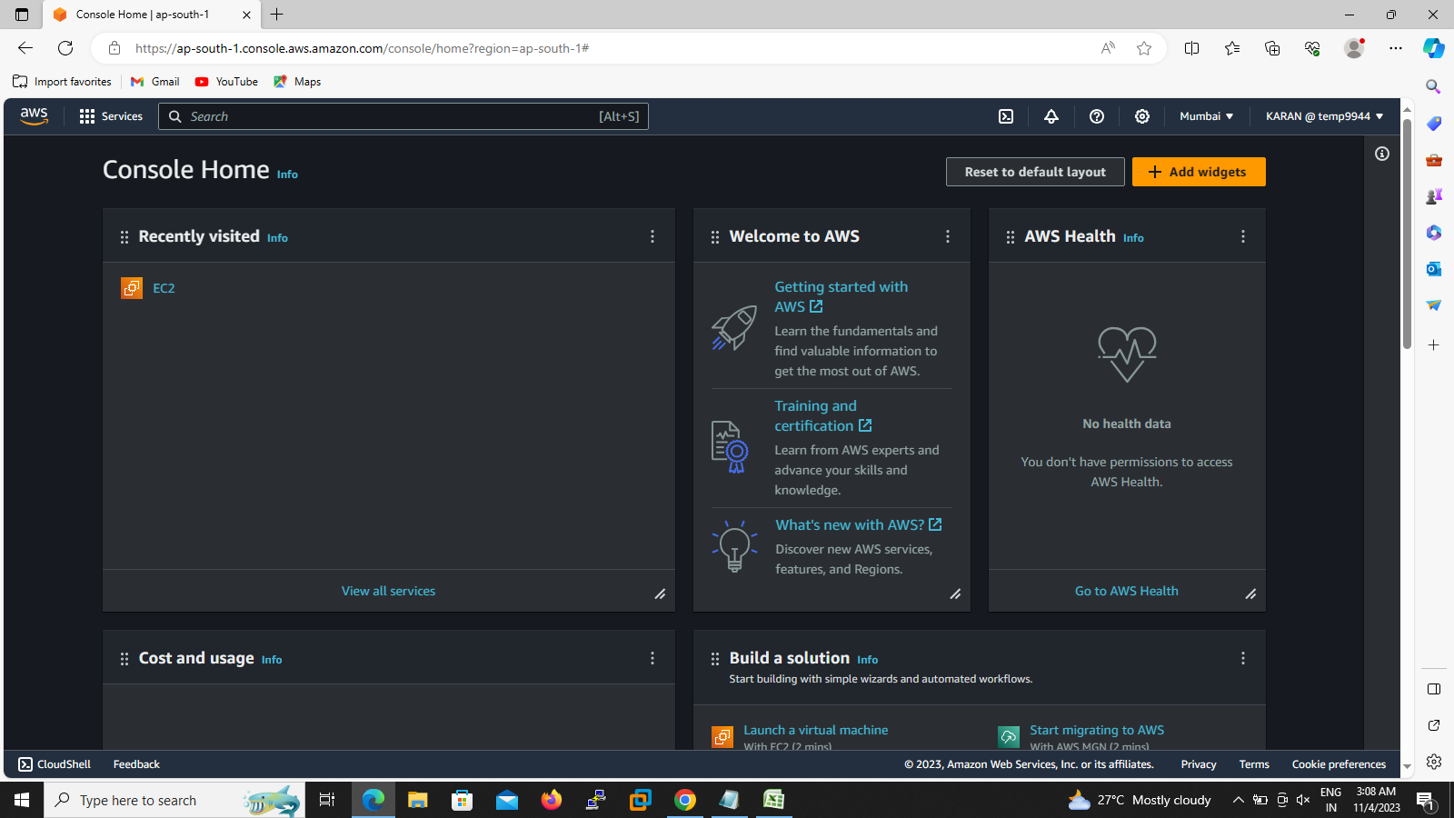

9.login to CLI so we want access key and secrete access key we go to IAM – SECURITY CREDENTIALS – CLI-Appear CLI Access key and secret access key

10.Go to CLI terminal enter Access key and secret access key and region

11. i go to launch instance by using my old instance ami id refer screenshot

